“The Spirituality of Blessed Louis and Zélie Martin,
the Parents of Saint Thérèse of Lisieux”
a series of conferences by Maureen O’Riordan
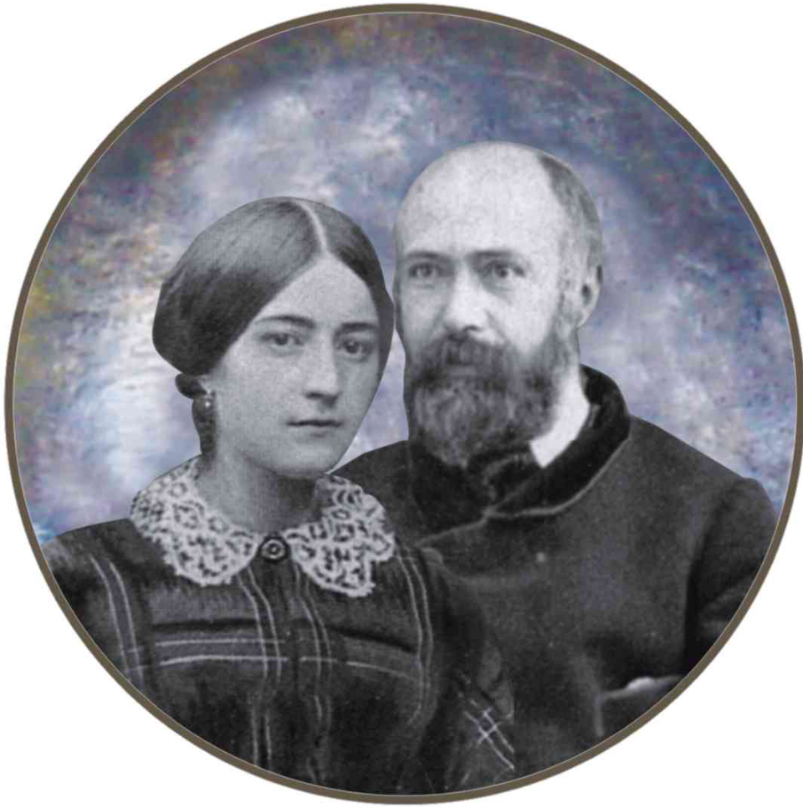
Monday, September 21  at 8:00 p.m. | Blessed Louis and Zélie Martin:  a family made holy in, through, and by marriage
Tuesday, September 22  at 11:00 a.m. | The challenge of being a Christian mother:  Blessed Zélie Martin  and the spiritual formation of children
Tuesday, September 22  at 8:00 p.m. | Blessed Louis Martin, the “incomparable father”  of St. Thérèse: how can he help Christian fathers today?
Wednesday, September 23  at 2:30 p.m. | “Lord, the one you love is sick”: the spirituality  of sickness and healing in the Martin family
Thursday, September 24  at 2:30 p.m. | Blessed Louis and Zélie Martin, ministers of charity  and justice: loving our neighbor and Christ’s poor
Thursday, September 24  at 8:00 p.m. | A map of the way of confidence and love  of St. Thérèse of Lisieux
Cathedral Basilica of Saints Peter and Paul
1723 Race Street, Philadelphia, Pa.

